SDK
SDK 1
windows system 2
Library import and use 2
C++ 4
1.Data structure description 4
2.Serial port communication 4
3.Network port communication 5
C 5
4.Data Structure 5
5.Serial port communication 5
6.Network port communication 6
Linux system 7
SO Library import and use（libXJC_SDK_Lib.so） 7
C++ 8
7.Serial port communication 8
8.Network port communication 9
C 9
9.Serial port communication 9
10.Network port communication 10

Windows system

Library import and use

- Environment configuration
a、Install the Visual Studio integrated development software in the Windows system and select the open source community version, as shown in Figure 1;

Figure 1
b、Open visual studio and select create a new project, as shown in Figure 2;
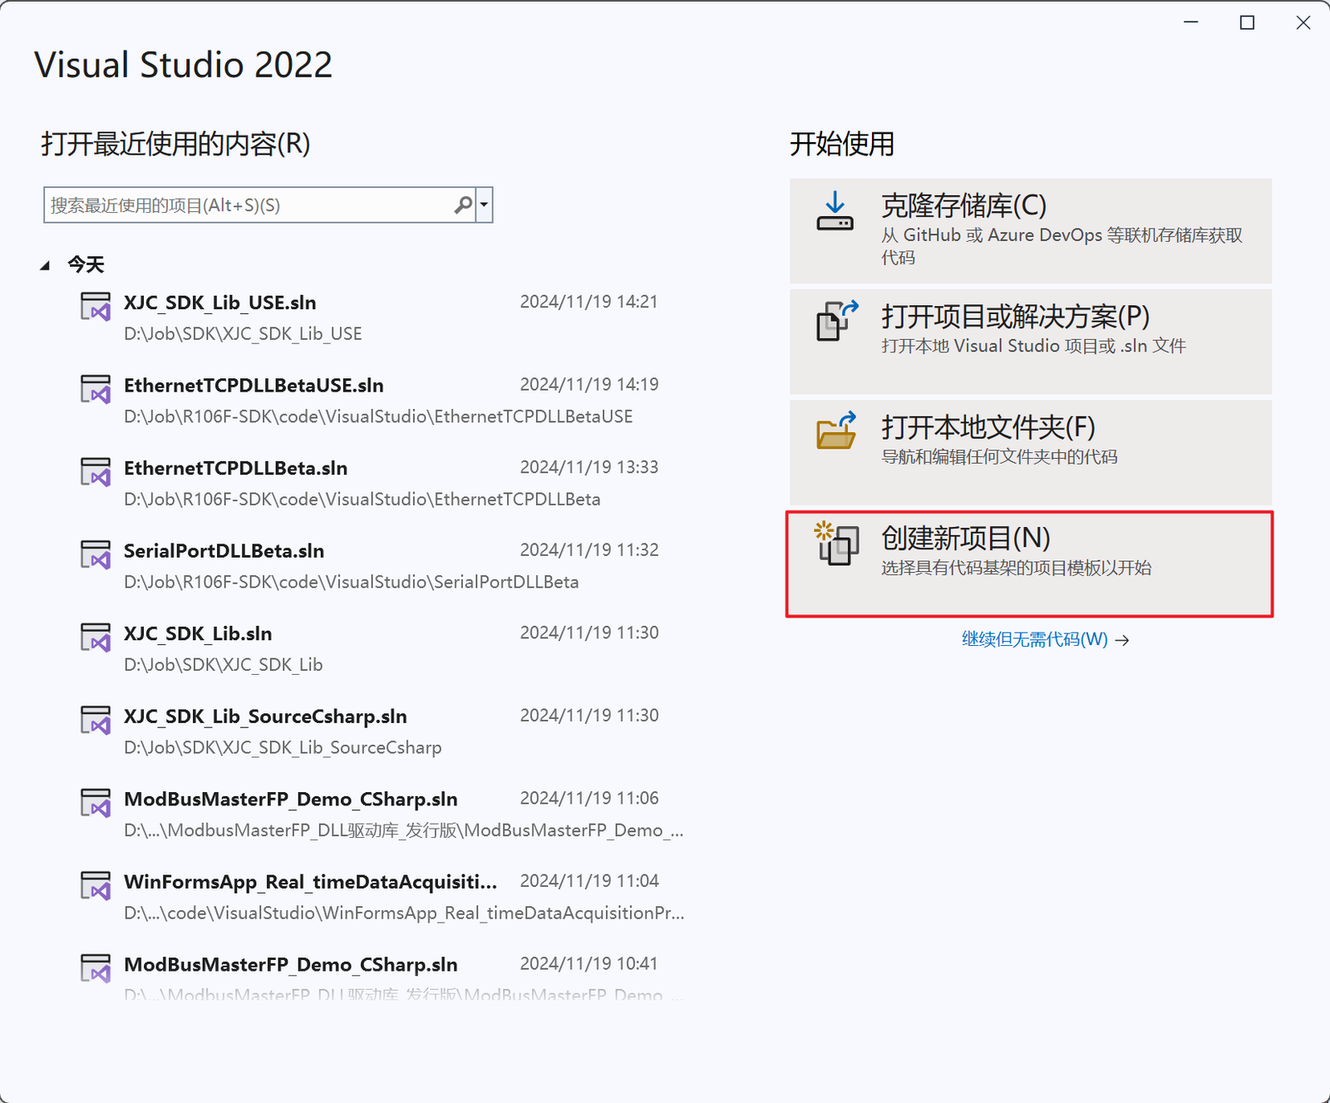
Figure 2
Select C++ as the language, and select console application as the template type, as shown in Figure 3;
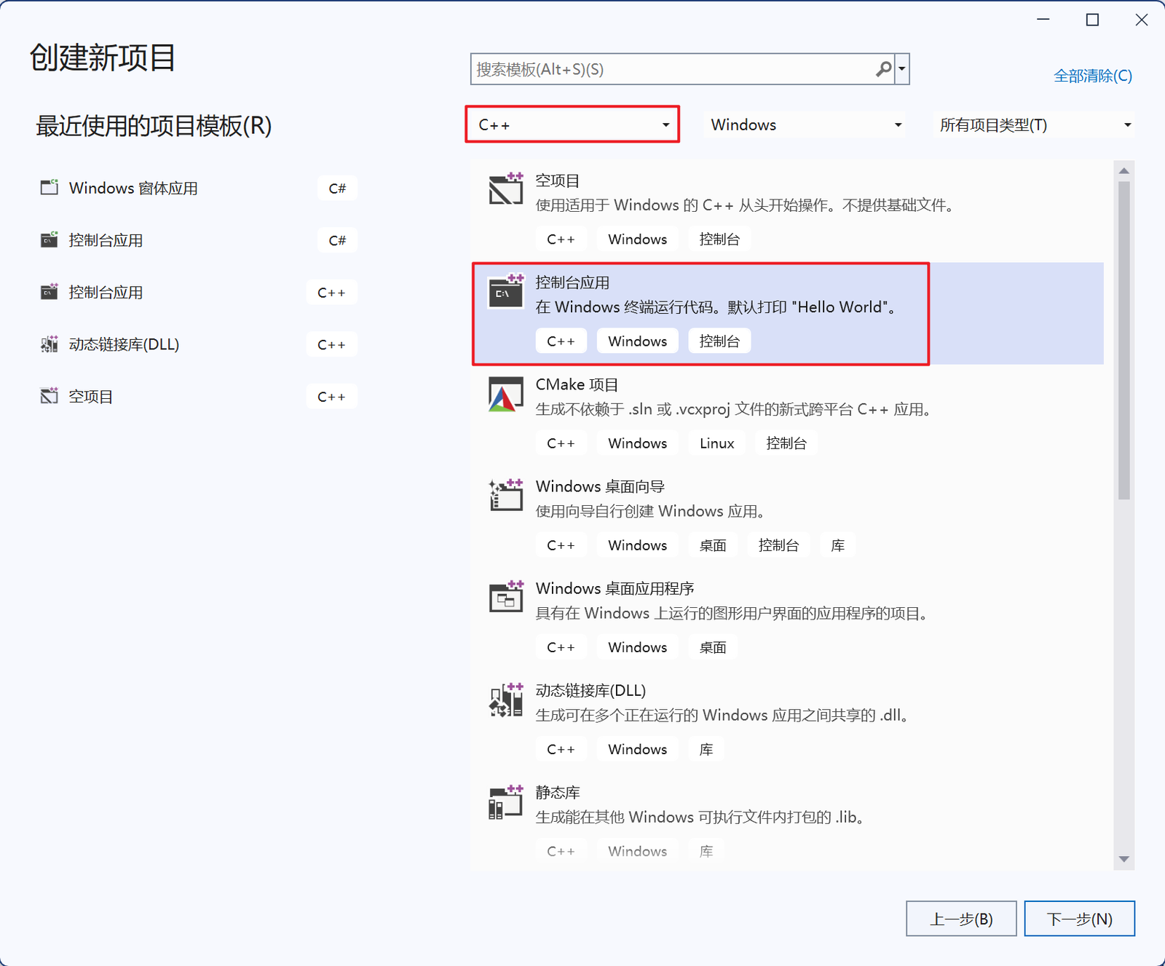
Figure 3
Click Next, enter the project settings, and click Create, as shown in Figure 4.
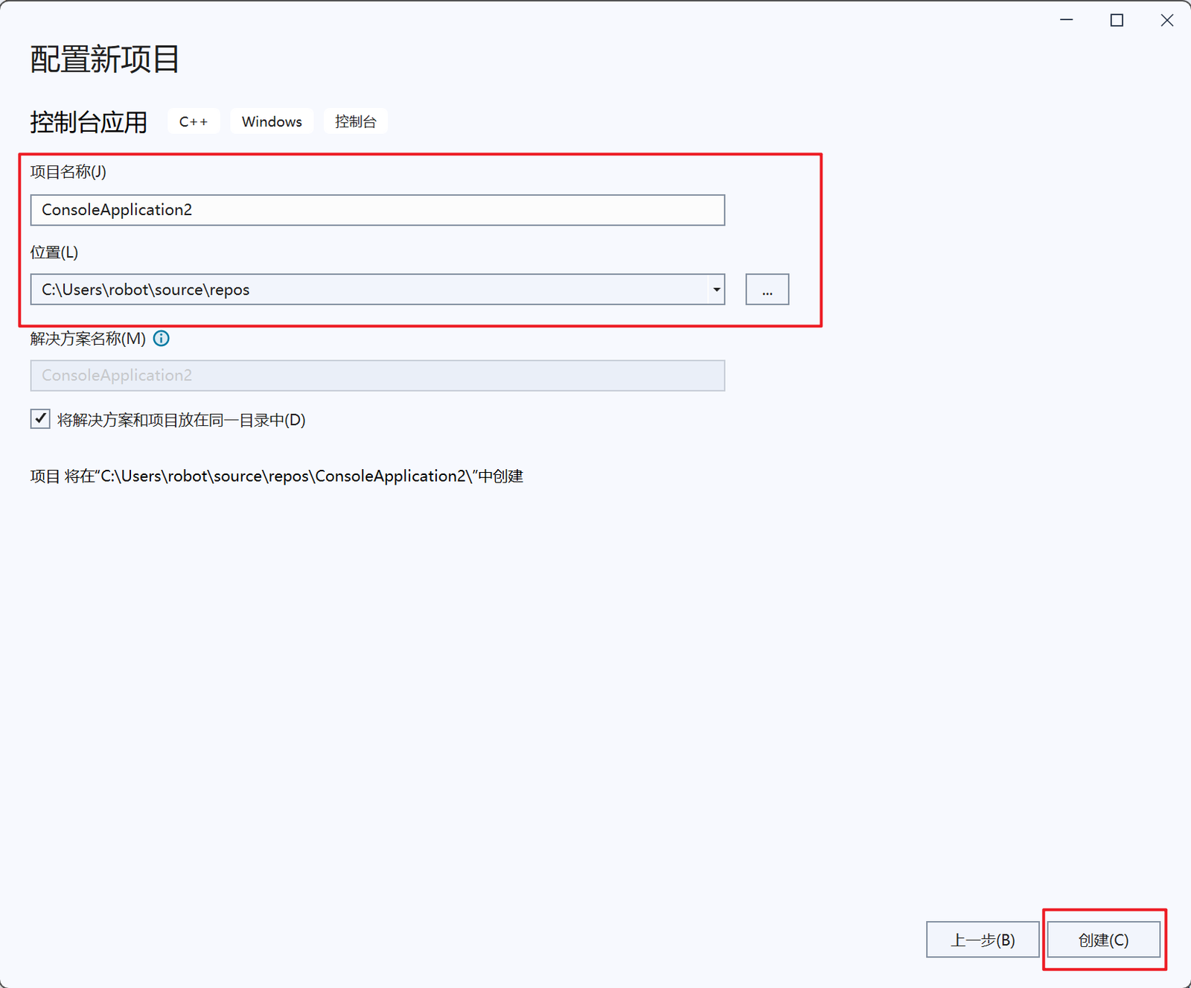
Figure 4
2 Library import
a、Copy XJC_SDK_Lib.h, XJC_SDK_Lib.dll and XJC_SDK_Lib.lib in the software package to the created project directory folder, as shown in Figure 5;
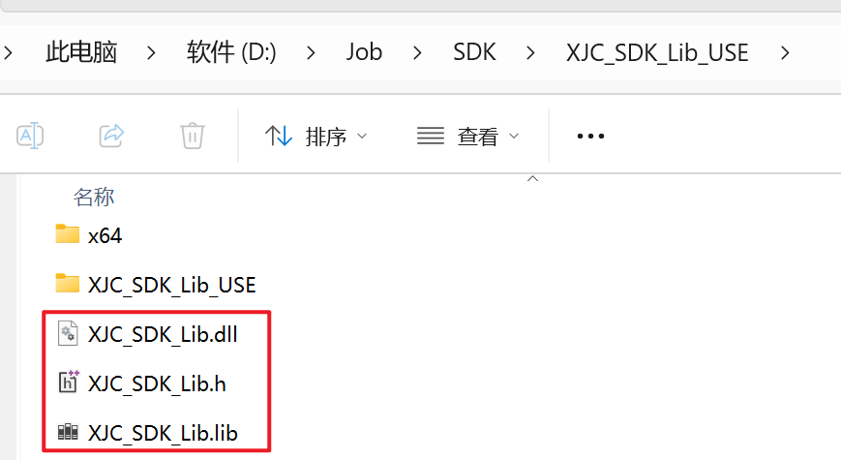
Figure 5
3 Use of the library
Note: You can directly use the XJC_SDK_Lib_USE.cpp code file for learning
a、For details on serial port communication, see "2. Serial port communication";
b、For details on network port communication, see "3. Network port communication";

C++

Data structure description

serial port communication
a、Create an object of the SerialPort class
XJC_SDK_Lib::SerialPort serialPort;
b、Set serial port information
// Serial port number, baud rate, sensor model
int result = serialPort.creatPort(L"COM7", 115200, "D82");
Return value 1 if successful, otherwise failed
c、Communicate and receive data
int result = serialPort.sendAndReceiveCommand();
Return value 1 if successful, otherwise failed
d、Get force sensor data
serialPort.getForceAndTorque(fx, fy, fz, mx, my, mz);
Return value true if successful, otherwise failed；fx, fy, fz, mx, my, mz are the force information of the sensor
e、Turn on the filtering function
serialPort.sendFilterOpenCommand();
Return value true if successful, otherwise failed
f、Turn off the wave filtering function
serialPort.sendFilterCloseCommand();
Return value true if successful, otherwise failed

Network port communication
a、Create an object of EthernetTCP class
XJC_SDK_Lib::EthernetTCP ethernettcpdllObj;
b、Prepare the parameters
const char* ipAddress = "192.168.1.28"; // Sensor device ip, default 192.168.1.28
const int port = 502; // Sensor device port number, default is 502
float fx, fy, fz, mx, my, mz; // Used to save and use 6-axis force sensor data
c、Get the force sensor data
int result = ethernettcpdllObj.GetForceSensorData(ipAddress, port, &fx, &fy, &fz,
&mx, &my, &mz); // Call the GetForceSensorData function and get the result
d、Turn on the wave filtering function
int res = ethernettcpdllObj.sendFilterOpenCommand(ipAddress, port);
Return value 1 if the opening is successful, otherwise the opening fails
f、Turn off the wave filtering function
int res = ethernettcpdllObj.sendFilterCloseCommand(ipAddress, port);
Return value 1 if the shutdown is successful, otherwise the shutdown fails

C

Data Structure

serial port communication
a、Create serial port object
XJC_SDK_Lib::SerialPort* sp = XJC_SDK_Lib::CreateSerialPort();
b、Prepare the parameters
const wchar_t* portName = L"COM7"; // Port number, set based on actual usage
int baudRate = 115200; // Device baud rate
const char* sensorName = "D80"; // Device Model
c、Create serial port
int result = XJC_SDK_Lib::CreatePort(sp, portName, baudRate, sensorName);
Return value 1 if successful, otherwise failed
d、Open serial port
XJC_SDK_Lib::OpenPort(sp)；
e、Data Communications
int result = XJC_SDK_Lib::SendAndReceiveCommand(sp);
Return value 1 if successful, otherwise failed
f、Get the force sensor data
XJC_SDK_Lib::GetForceAndTorque(sp, &fx, &fy, &fz, &mx, &my, &mz)；
Return value true if successful, otherwise failed；&fx, &fy, &fz, &mx, &my, &mz are the force information of the sensor
g、Turn on the wave filtering function
XJC_SDK_Lib::SendFilterOpenCommand(sp)；
Return value true if successful, otherwise failed
h、Turn off the wave filtering function
XJC_SDK_Lib::SendFilterCloseCommand(sp)
Return value true if successful, otherwise failed
i、Destroy serial port object
XJC_SDK_Lib::DestroySerialPort(sp);

Network port communication
a、Create network port object
XJC_SDK_Lib::EthernetTCP* tcpInstance = XJC_SDK_Lib::CreatEthernetTCP();
b、Prepare the parameters
const char* ipAddress = "192.168.1.28"; // Device ip
int port = 502; // Device port number
c、Get the force sensor data
int result = XJC_SDK_Lib::GetForceSensorData(tcpInstance, ipAddress, port, &fx, &fy, &fz, &mx, &my, &mz);
Return value 1 if successful, otherwise failed；&fx, &fy, &fz, &mx, &my, &mzare the force information of the sensor
d、Turn on the wave filtering function
XJC_SDK_Lib::TCPSendFilterOpenCommand(tcpInstance, ipAddress, port)；
Return value 1 if successful, otherwise failed
e、Turn off the wave filtering function
XJC_SDK_Lib::TCPSendFilterCloseCommand(tcpInstance, ipAddress, port)；
Return value 1 if successful, otherwise failed

Linux system

SO Library import and use（libXJC_SDK_Lib.so）
a、Import libXJC_SDK_Lib.soin the software package to the lib folder and build the recommended file framework format, as shown in Figure 1；
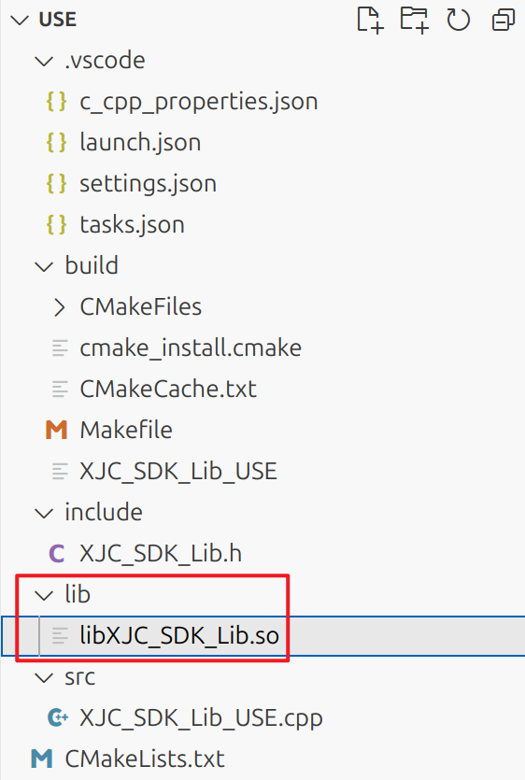
Figure 1
b、Write the CMakeLists.txt file (refer to the examples provided by the software package), and then compile it in the build folder. The reference instructions are as follows
After success, relevant files will be generated in the build folder, and the executable file will be found, as shown in Figure 2
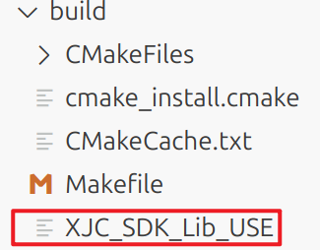
Figure 2
c、To configure launch.json and task.json, please refer to the sample code in the software package.
d、“Run” -> "Start Debugging" Start debugging and execution and it is ready to run.

C++

serial port communication
a、Create an object of SerialPort class.
XJC_SDK_Lib::SerialPort serialPort;
b、Set serial port information
// Serial port number, baud rate, sensor model
int result = serialPort.creatPort(L"/dev/ttyACM0", 115200, "D80");
Return value 1 if successful, otherwise failed
c、Open serial port
serialPort.openPort()
Return value true if successful, otherwise failed
d、Communicate and receive data
int result = serialPort.sendAndReceiveCommand();
Return value 1 if successful, otherwise failed
e、Get force sensor data
serialPort.getForceAndTorque(fx, fy, fz, mx, my, mz);
Return value true if successful, otherwise failed；fx, fy, fz, mx, my, mz are the force information of the sensor
f、Turn on the wave filtering function
serialPort.sendFilterOpenCommand();
Return value true if successful, otherwise failed
g、Turn off the wave filtering function
serialPort.sendFilterCloseCommand();
Return value true if successful, otherwise failed

Network port communication
a、Create an object of EthernetTCP class
XJC_SDK_Lib::EthernetTCP ethernettcpdllObj;
b、Prepare the parameters
const char* ipAddress = "192.168.1.28"; // Sensor device ip, default 192.168.1.28
const int port = 502; // Sensor device port number, default 502
float fx, fy, fz, mx, my, mz; // Used to save and use 6-axis force sensor data
c、Get the force sensor data
int result = ethernettcpdllObj.GetForceSensorData(ipAddress, port, &fx, &fy, &fz,
&mx, &my, &mz); // Call the GetForceSensorData function and get the result
d、Turn on the wave filtering function
int res = ethernettcpdllObj.sendFilterOpenCommand(ipAddress, port);
Return value 1 if the opening is successful, otherwise the opening fails
f、Turn off the wave filtering function
int res = ethernettcpdllObj.sendFilterCloseCommand(ipAddress, port);
Return value 1 if the shutdown is successful, otherwise the shutdown fails

C

serial port communication
a、Create serial port object
XJC_SDK_Lib::SerialPort* sp = XJC_SDK_Lib::CreateSerialPort();
b、Prepare the parameters
const wchar_t* portName = L"COM7"; // Port number, set based on actual usage
int baudRate = 115200; // Device baud rate
const char* sensorName = "D80"; // Device model
c、Create serial port
int result = XJC_SDK_Lib::CreatePort(sp, portName, baudRate, sensorName);
Return value 1 if successful, otherwise failed
d、Open serial port
XJC_SDK_Lib::OpenPort(sp)；
e、Data Communications
int result = XJC_SDK_Lib::SendAndReceiveCommand(sp);
Return value 1 if successful, otherwise failed
f、Get the force sensor data
XJC_SDK_Lib::GetForceAndTorque(sp, &fx, &fy, &fz, &mx, &my, &mz)；
Return value true if successful, otherwise failed；&fx, &fy, &fz, &mx, &my, &mz are the force information of the sensor
g、Turn on the wave filtering function
XJC_SDK_Lib::SendFilterOpenCommand(sp)；
Return value true if successful, otherwise failed
h、Turn off the wave filtering function
XJC_SDK_Lib::SendFilterCloseCommand(sp)
Return value true if successful, otherwise failed
i、Destroy the serial port object
XJC_SDK_Lib::DestroySerialPort(sp);

Network port communication
a、Create network port object
XJC_SDK_Lib::EthernetTCP* tcpInstance = XJC_SDK_Lib::CreatEthernetTCP();
b、Prepare the parameters
const char* ipAddress = "192.168.1.28"; // Device ip
int port = 502; // Device port number
c、Get the force sensor data
int result = XJC_SDK_Lib::GetForceSensorData(tcpInstance, ipAddress, port, &fx, &fy, &fz, &mx, &my, &mz);
Return value 1 if successful, otherwise failed；&fx, &fy, &fz, &mx, &my, &mz are the force information of the sensor
d、Turn on the wave filtering function
XJC_SDK_Lib::TCPSendFilterOpenCommand(tcpInstance, ipAddress, port)；
Return value 1 if successful, otherwise failed
e、Turn off the wave filtering function
XJC_SDK_Lib::TCPSendFilterCloseCommand(tcpInstance, ipAddress, port)；
Return value 1 if successful, otherwise failed

